AudioCloud
Software Requirements Specification

Version 1.0



Group Id: S19020E3FC
Supervisor Name: Muhammad Saeed (muhammad.saeed@vu.edu.pk)

Revision History

Date (dd/mm/yyyy) | Version | Description | Author
30 May 2019 | 1.0 | A platform which provide an opportunity to users to upload, download and share audio files to others | BC140400342  BS140401325

Table of Contents

- Scope (of the project)
- Functional Requirements Non Functional requirements
- Use Case Diagram
- Usage Scenarios
- Adopted Methodology
- Work Plan (Use MS Project to create Schedule/Work Plan)

SRS Document

Scope of Project:

The aim of this project is to develop a website named as audio cloud. Basic scope of this project is to provide a platform for people to upload, download and share their audio files of different categories to other people. Users can share audio files of this platform to social media like Facebook, Twitter, WhatsApp, etc. Users will be able to search, play audio file online, like/dislike, share and download all public audio files. Users can create and manage their playlists of their favorite audio files. So that, they can play their playlist in future.

Functional Requirements:

These are the functional requirements of this project
- Register
Website users can register themselves on this platform to get access of uploading module to share their audio files to others.
- Email verification link generator
This function generates an email verification link which is sent to the user’s email for validation of email address.
- Email confirmation
This module validates the email address and authorizes the user to login to the website
- Login
This module gets the email/username of user to login the user with correct password.
- Admin approval of uploading permission of newly registered user
This module only visible to administrator of website. Through this module, admin can approve the registered user’s profile to make them able to post their new audio files on the platform.
- Uploading audio files as public/private
This module is visible to the approved registered users and admin to upload the new audio files with their details like: - title, description, vocalist etc
- Online audio player
There is an embedded online audio player on the website. Through that, every user can play their desired audio file which is available on the platform.
- Create and manage playlist
Through this module, users can create and manage their playlist/s which is/are also stored on the platform with their respective user. A user can add, remove audio files in their created playlist. They can also change the name of playlist.

- Search audio files
This module search audio files according to the desired method like with title, date of posting or with the category of audio files. This module show the results with descending order with respect to the listen count, relevance, duration of audio file, like and dislike count.
- Like or dislike of audio file
This function provide a mechanism to the registered user to like or dislike any public audio file which is available on the platform.
- Listen count
This function store the value of how many time the audio file is played on the platform.
- Duration of audio file
This function checks the duration of audio file when a user uploads that file.
- Embedded code
There is an embedded code available for every audio file to give users an opportunity to share that file on their website and other social platforms.
- Sharing feature on social media
Through this function, users can share any public audio file to their social media profile timeline like Facebook, WhatsApp etc.

Non Functional Requirements:-
Some non-functional requirements of platform are below:
- Operating System
This platform runs both on Linux as well as windows operating system.
- Localhost environment
You can also run it on localhost environment to check the platform is running correctly or not.
- Debugging and error displaying
Platform is so much reliable that, if it has an error on a module, it can show the exact error along with detail description of that error. So that, you can search and solve that error without any proper knowledge about programming.
- Fast response time
Platform use MySQL data base with PHP language. So that, it runs very fast and get results in very quick time.
- Best User Interface
Platform has a beautiful user interface to give the best environment and best user experience to the end users.

Use Case Diagram(s):-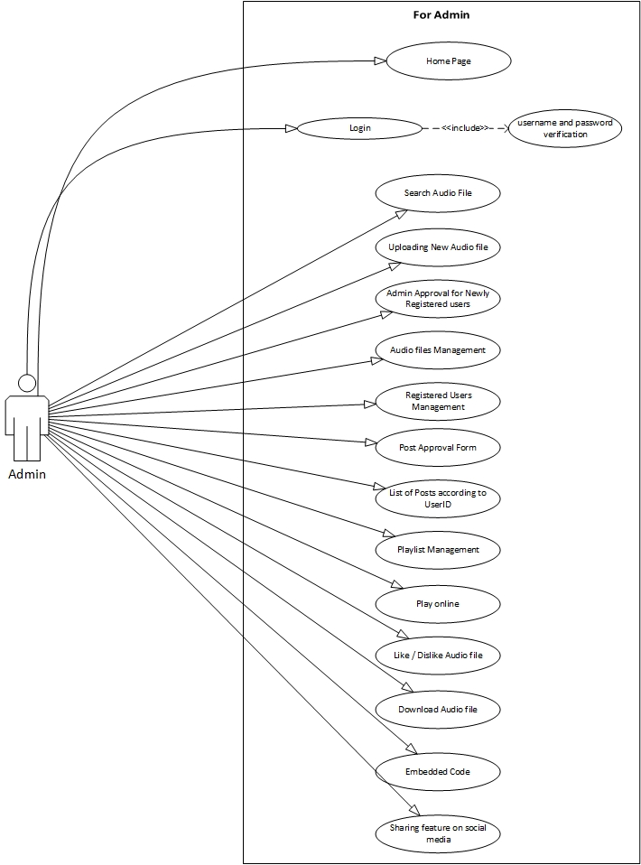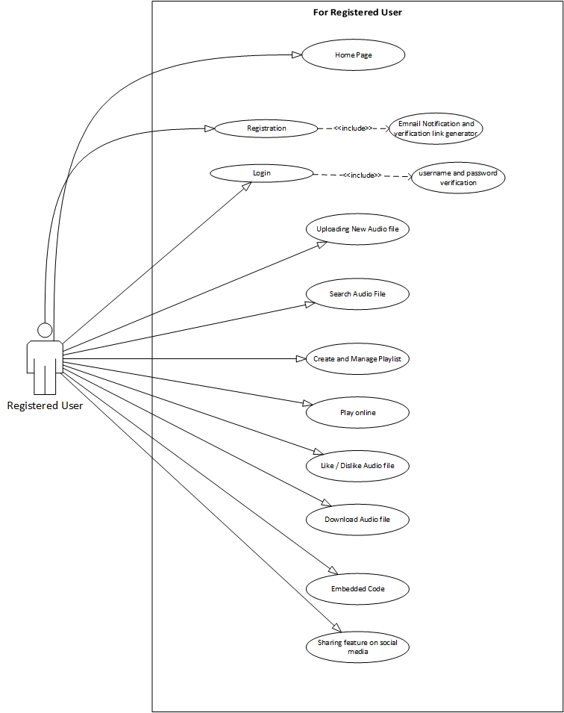
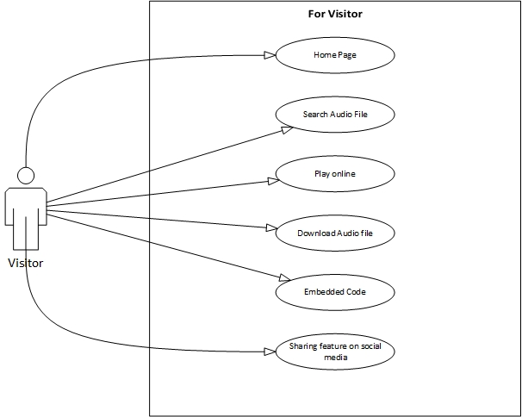

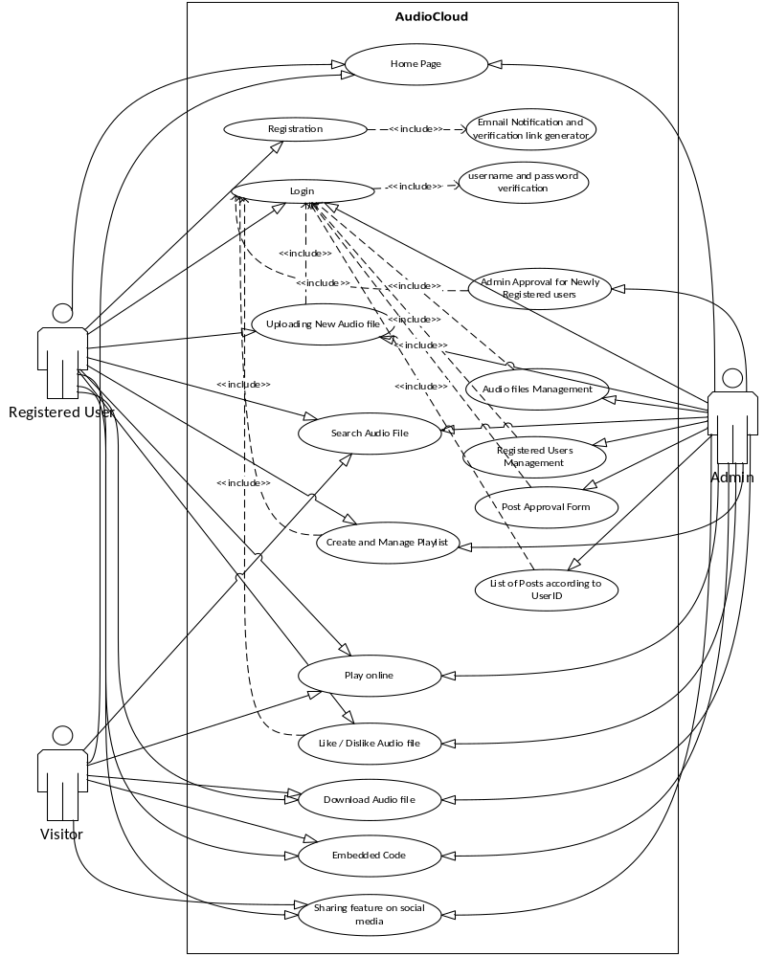

Usage Scenarios:-

- Home Page

Use Case Title | Home Page
Use Case ID | audioCloud_main()
Actions | Search first 30 audio files according to newly uploaded, listen count and like
Description | This is the main webpage of the website, which have navigation links, search box, login and register link. There are 30 latest audio files shown on this page for visitors.
Alternative Paths | Nill
Pre Conditions
Post Conditions
Author | S19020E3FC (BC140400342,BS140401325)
Exceptions | Nill

- Registration

Use Case Title | Registration
Use Case ID | Register_newUser()
Actions | - Register new user on platform  - Send email verification link to the given user email address
Description | This webpage gets the user information like username, first and last name, email , password and store this information to database
Alternative Paths
Pre Conditions | Nill
Post Conditions | All required fields are filled with proper information
Author | S19020E3FC (BC140400342,BS140401325)
Exceptions | Missing field information, Password is less than 6 digits, password and confirm password did not match

- Login

Use Case Title | Login
Use Case ID | User_Login
Actions | Login the user to platform
Description | This module checks the username and password of a user to give him the registered user access.
Alternative Paths | If username does not exist in database or password is incorrect then an error is prompted on screen that username and password did not match, There is also a “Forget Password” page to recover the password of existing account
Pre Conditions | Nill
Post Conditions | If a user enter correct username with correct password then he/she will get the registered user rights access
Author | S19020E3FC (BC140400342,BS140401325)
Exceptions | User Name and password did not match

- Uploading New Audio File

Use Case Title | Uploading New Audio File
Use Case ID | uploading_newFile()
Actions | Upload an audio file to the platform with given information from authorized register user
Description | This webpage gets the information about the audio file like title, description, category, etc and audio file from user and store this information in database and audio file in audioBank folder
Alternative Paths
Pre Conditions | User must login to get access to this webpage
Post Conditions | Page refresh with confirmation of uploading to audio file.
Author | S19020E3FC (BC140400342,BS140401325)
Exceptions | If a file is not uploaded properly, then a prompted message is show on user screen about this error and ask him/her to try again.

- Search Audio File

Use Case Title | Search Audio File
Use Case ID | Search_AudioFile()
Actions | Search audio files in the database according to title, uploading date and category. Also sort the result of database according to listen count, likes and length of audio file
Description | This webpage show the results of give searched word from user according to the given method like with title, uploading date or category
Alternative Paths
Pre Conditions | User should already login on the platform
Post Conditions | Show the results of search words
Author | S19020E3FC (BC140400342,BS140401325)
Exceptions | If the searching words are not present in database, no audio file is shown on result page

- Create and Mange Playlist

Use Case Title | Create and Manage Playlist
Use Case ID | playlist_management()
Actions | Create new playlist and add audio files in it or do some changes in existing playlist
Description | Through this module, a registered user can create and manage the existing playlist on the platform, A registered user can add new audio file and delete old file from the playlist.
Alternative Paths | Nill
Pre Conditions | A should already login into platform.
Post Conditions | Showing updated playlist like audio file is deleted or new file is added.
Author | S19020E3FC (BC140400342,BS140401325)
Exceptions | Nill

- Admin Approval for Newly Registered Users

Use Case Title | Admin Approval for Newly Registered users
Use Case ID | newUser_approval()
Actions | Admin can approve a user for uploading audio files
Description | This module is for admin. Through this module admin can approve a new user to authorize him/her to upload audio files on the platform.
Alternative Paths | Nill
Pre Conditions | New user is already verified his/her email address.
Post Conditions | A user is authorized for uploading audio files on the platform.
Author | S19020E3FC (BC140400342,BS140401325)
Exceptions | Nill

- Post Approval Form

Use Case Title | Post Approval Form
Use Case ID | newPost_Approval()
Actions | Every public post needs attention of admin to approve it. So that, that post is shown on the platform to everyone.
Description | Through this module, Admin approve every new public post on the platform.
Alternative Paths | Nill
Pre Conditions | Authorized user uploaded an audio file.
Post Conditions | Post or Audio file is shown to every visitor of the platform.
Author | S19020E3FC (BC140400342,BS140401325)
Exceptions | Nill

- Audio Files Management

Use Case Title | Audio Files Management
Use Case ID | file_manangement()
Actions | - Editing file title, description, etc  - Editing uploaded User Credit about this file  - Delete Audio file from the platform
Description | This is the admin module. Through this module admin can edit file title, description, etc including username which uploaded that file.
Alternative Paths | Nill
Pre Conditions | Admin login to platform
Post Conditions | Show updated platform to every one
Author | S19020E3FC (BC140400342,BS140401325)
Exceptions | Nill
- Registered User Management

Use Case Title | Registered Users Management
Use Case ID | User_management()
Actions | - Change user account password  - Edit user account information  - Delete user account
Description | This is the admin module. Through this module, admin can change every possible thing about the user account. Admin can also delete the user account.
Alternative Paths | Nill
Pre Conditions | Nill
Post Conditions | Show updated platform to everyone.
Author | S19020E3FC (BC140400342,BS140401325)
Exceptions | Nill

- List of Post according to UserID

Use Case Title | List of Posts according to UserID
Use Case ID | Postlist_with_UserID()
Actions | This is admin module. Through this module, Admin can view the post list through the user id.
Description | This module let the admin see all post of a user through his/her user id. This module also tells the likes, Dislikes, listen count and length of the audio file.
Alternative Paths | Nill
Pre Conditions | - Admin is logged in  - Admin give id of any registered user
Post Conditions | Platform shows the list of post which a user posted according to date of posting
Author | S19020E3FC (BC140400342,BS140401325)
Exceptions | - User id is not valid  - User account is not approved for uploading

- Play online

Use Case Title | Play Online
Use Case ID | onlinePlayer()
Actions | Get file from the platform and play on web browser on end user side
Description | Through this module an online audio player is added on end user webpage and user can play any audio file of the platform through this player.
Alternative Paths | Nill
Pre Conditions | Nill
Post Conditions | Playing audio file at 70% loudness
Author | S19020E3FC (BC140400342,BS140401325)
Exceptions | Nill
- Like or Dislike Audio File

Use Case Title | Like / Dislike Audio File
Use Case ID | Like_Dislike()
Actions | Increase the number of like and dislike of the audio file
Description | This function is used by admin and registered user only to like and dislike any public audio file of the platform
Alternative Paths | Nill
Pre Conditions | User or admin is logged in to the platform
Post Conditions | Show the updated like or dislike count to the users
Author | S19020E3FC (BC140400342,BS140401325)
Exceptions | Nill

- Download Audio File

Use Case Title | Download Audio File
Use Case ID | Download()
Actions | Send selected audio file to the end user
Description | This option is available to every user either it is a registered user or a visitor to download the desired audio file
Alternative Paths | Nill
Pre Conditions | Clicked on the download icon
Post Conditions | File is downloaded to the user browser
Author | S19020E3FC (BC140400342,BS140401325)
Exceptions | Nill

- Embedded Code

Use Case Title | Embedded Code
Use Case ID | Embedded_Code_Generator()
Actions | Option to give the embedded code to the end user to share the audio file to other website
Description | This option gives the embedded code of the audio file of the platform to the user. So that, the user share it on some other website
Alternative Paths | Nill
Pre Conditions | Nill
Post Conditions | Copy the embedded code to the user’s computer clip board.
Author | S19020E3FC (BC140400342,BS140401325)
Exceptions | Nill

- Sharing feature on Social Media

Use Case Title | Sharing feature on Social Media
Use Case ID | Share_onSocialMedia()
Actions | Share the selected audio file to the selected social media like Facebook, Whatsapp, etc
Description | This function gives an option to the end user to share selected audio file to social media like Facebook, Whatsapp, etc
Alternative Paths | Nill
Pre Conditions | Nill
Post Conditions | Shared audio file to selected social media.
Author | S19020E3FC (BC140400342,BS140401325)
Exceptions | Nill

Adopted Methodology

Exiting Methodologies:-
A number of methodologies exist now a days and a variety of model used various people to their need and nature of their work.

Water Fall Methodology;-
The water fall methodology goes to the cycle of analysis, design, coding, testing, and maintenance. The simplest version of this is called the "waterfall" methodology.

- The systems services, constraints and goals are defined by consulting the system with users
- The requirement is classified into hardware and software systems. It gives overall architecture of the system.
- The system is installed and gives to practical use. The system checks errors, corrects them and improve it.

Spiral Methodology;-
- To avoid the risk that might be faced in development of software the spiral methodology is used. For example, the risk might be a resignation from the key person
- There are two dimensions in a Spiral Model; A Radial dimension which represents the cumulative cost to date, and an angular dimension which represents the progress through the spiral.
- The spiral model is very sensitive to risks. Due to its spiral nature the development and maintenance run in parallel. This method is used for development of large-scale and in-house software.

Adopted Methodology;-
As per requirement, we will adopt the methodology named, “VU process model”. The description of which is given below:

VU Process Model:-
It is the combination of waterfall methodology and spiral methodology. It is also called hybrid approach of system development. It has five phases and which are Gathering and analyzing requirement, planning, analysis and design, development and final report.
In the requirement phase the system goals, services and constrains are established after discussion with user. The planning phase is synchronized effort to find all the potential roadblocks and draft a robust plan to tackle each. This phase usually involves a lot of brainstorming within software development team as well as with respective client. It maximizes the quality of system and minimizes any risks and errors.

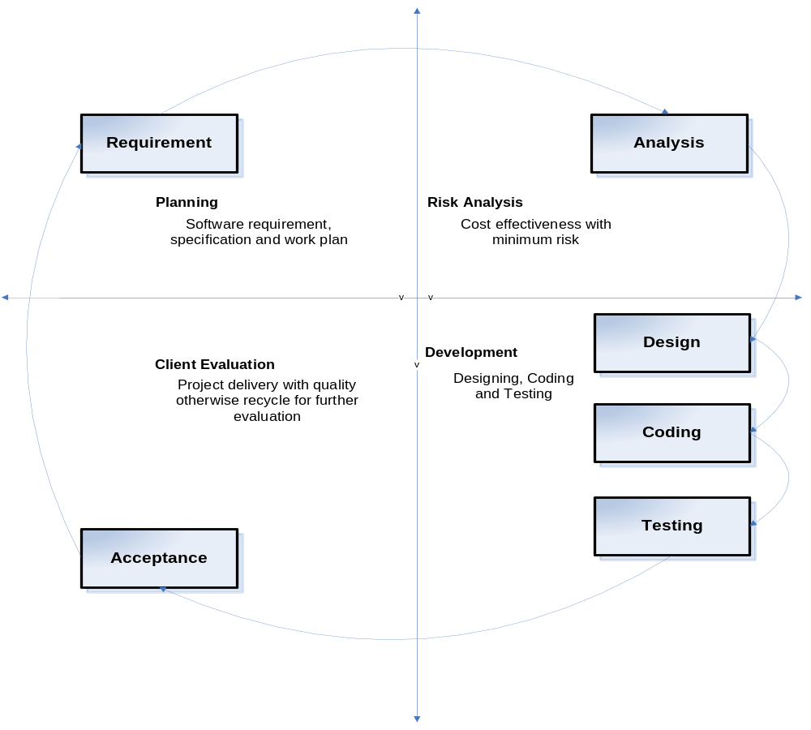

Reasons for choosing the Methodology:-
Following are the reasons for choosing VU Process.
Our project is divided already into different phases i.e. gathering and analyzing requirements phase, planning phase, analysis and design phase, development & final project report phase, and final report/viva phase.
We will complete each phase in sequence and will submit it to our supervisor. He will suggest us about the improvement in each phase before starting the next phase. We will make improvement in that phase. This process will be adopted due to the spiral nature of VU Process model. When the phase is well-improved and well worked-out, and also accepted by our Supervisor then we will proceed to next phase. This will be done due to the waterfall nature of the VU Process model. Hence both models are suppressed in single form and that will be our VU process model. It will provide error free result as each step is done in a sequence.

Work Plan (Use MS Project to create Schedule/Work Plan)

